FIRST MEETING WITH THE CLIENT 1/9/23

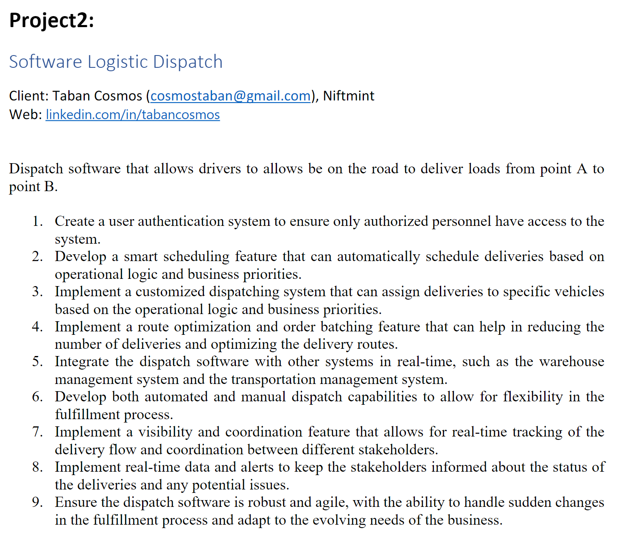

Questions to ask:

Booking for data (like doordash)

1. Specific programming language or target platform desired? **Java javascript**
2. What type of application? Mobile app for tracking. React native xpo react native js google maps api backend sql mongo db node js, Quarkus or Springboot
3. What operating system(s) will use this product? Latest 3 versions below
4. What hardware will be running this software?
5. Related to points 2,3 what do you mean by operational logic and business priorities could you elaborate?
6. For point 5, what other systems will the dispatch software need to integrate with? What languages / architectures do those systems use? Can they be integrated remotely?

X it out

1. What does smart/automatically scheduling drivers consist of? Routes and time to leave?
2. What does route optimization and order batching consist of?
3. Are the routes already given? Or do we have to create and then later optimize the routes? Created by us
4. Where are we delivering orders to? Just a city, state, all of the US, international? USA
5. Where are the warehouses located? Driver and a warehouse
6. Related to point 1, Are there different roles for the application? Driver vs stakeholder? Other types of users? Driver, warehouse
7. What is the capacity of the vehicles that are doing the deliveries in terms of order space? When an order is placed will we know the volume that order will take up in the delivery vehicle? Get data for dot for trucks, fake data for products
8. For point 8 will the drivers have to confirm that an order is delivered? Signed deliveries special ID for drivers
9. How secure should the authentication system be?
10. What kind of roads does the software need to consider?
11. For point 7 what is a coordination feature?
12. How intensive should the tracking be?
13. What sudden changes do we need to expect? Road closures?
14. Do orders need to be signed for?
15. Non functional requirements?

**Note:**

Language: Java, React, javascript

* Like metro tracking system, use google map API for real time tracking

Target platform: Desktop, Mobile for only for tracking/for loads using React Native,

**React native EXPO- use expo containers to run in cross platform**

Backend: mysql or mongoDB, node js and sockets

**Framework - Java sprigboot or Quarkus framework**

Operational logic and Business priorities: check out or dropped off

Routes - routes are created by us, where we pickup to destinated and optimized by us, Routes within states

Warehouses located point A - driver and warehouse

Roles - driver, warehouse(provider)

Load of order - fake data for products

Tracking ID for vehicles- needs to be signed for when dropped off

Security - google oAuth

Non functional - focus on UI design, state change to pick up drop off or delay,

Like a timeline of map

Can click the car and gets info about the loads